Tasks

1.Visit a local retail shop (or use Google Images/Street View if you can't go in person) and take a photo or screenshot of a store display you think is eye-catching. Write 3 reasons why this display attracts attention based on its use of color, lighting, or product placement.

2.Sketch a window display for a new sneaker launch, inspired by how brands like Nike or Adidas do it in malls or on Myntra banners. Label key elements like focal point, props, and signage in your sketch.<br><br><em><strong>Hint:</strong> Focus on how you would make someone stop and look, even if they were just passing by.</em>

3.Redesign the product arrangement for a small mobile accessories shop so that the most popular items (like headphones and chargers) are more visible and accessible. List the changes you would make and explain how each change could improve sales.

4.Imagine you are planning an in-store display for a new IPL cricket merchandise collection. Create a simple plan (bullet points or a diagram) showing where you would place banners, mannequins, and products to maximize customer interest.<br><br><em><strong>Hint:</strong> Think about foot traffic flow and which areas get the most attention when people enter.</em>

Answer:-

1. Eye-catching store display
Store display chosen: Nike-style sneaker store window display
Maine ek sneaker-store window display choose kiya jisme colourful shoes transparent acrylic shelves par arranged hain. Aise display mein bright colours aur multiple sneaker pairs passing shoppers ka attention quickly capture karte hain.

3 reasons why it attracts attention
A Nike store window display in a mall featuring two mannequins dressed in athletic wear, with a large yellow Nike swoosh logo above them and sale signs visible.
- Bright colour contrast: Green, blue, red aur pastel sneakers dark/neutral store background ke against pop hote hain. Different colours display ko visually energetic banate hain.
- Eye-level product placement: Shoes transparent shelves par eye level ke around rakhe gaye hain. Isse passer-by ko products clearly dikhte hain aur unhe shop ke andar jaakar close-up dekhne ka interest hota hai.
- Clean lighting and open space: Transparent shelves aur glass window ke through light reflect hoti hai. Display overcrowded nahi lagta; har sneaker alag se visible rehta hai. Nike mall displays mein big logo, mannequins aur sale signage bhi use kiye jaate hain, jo brand recall aur visibility improve karte hain.

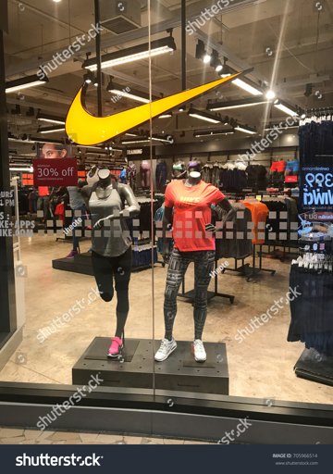

2. New sneaker-launch window display
Store name: KICKVERSE
Sneaker launch: KICKVERSE Neon Rush 1.0

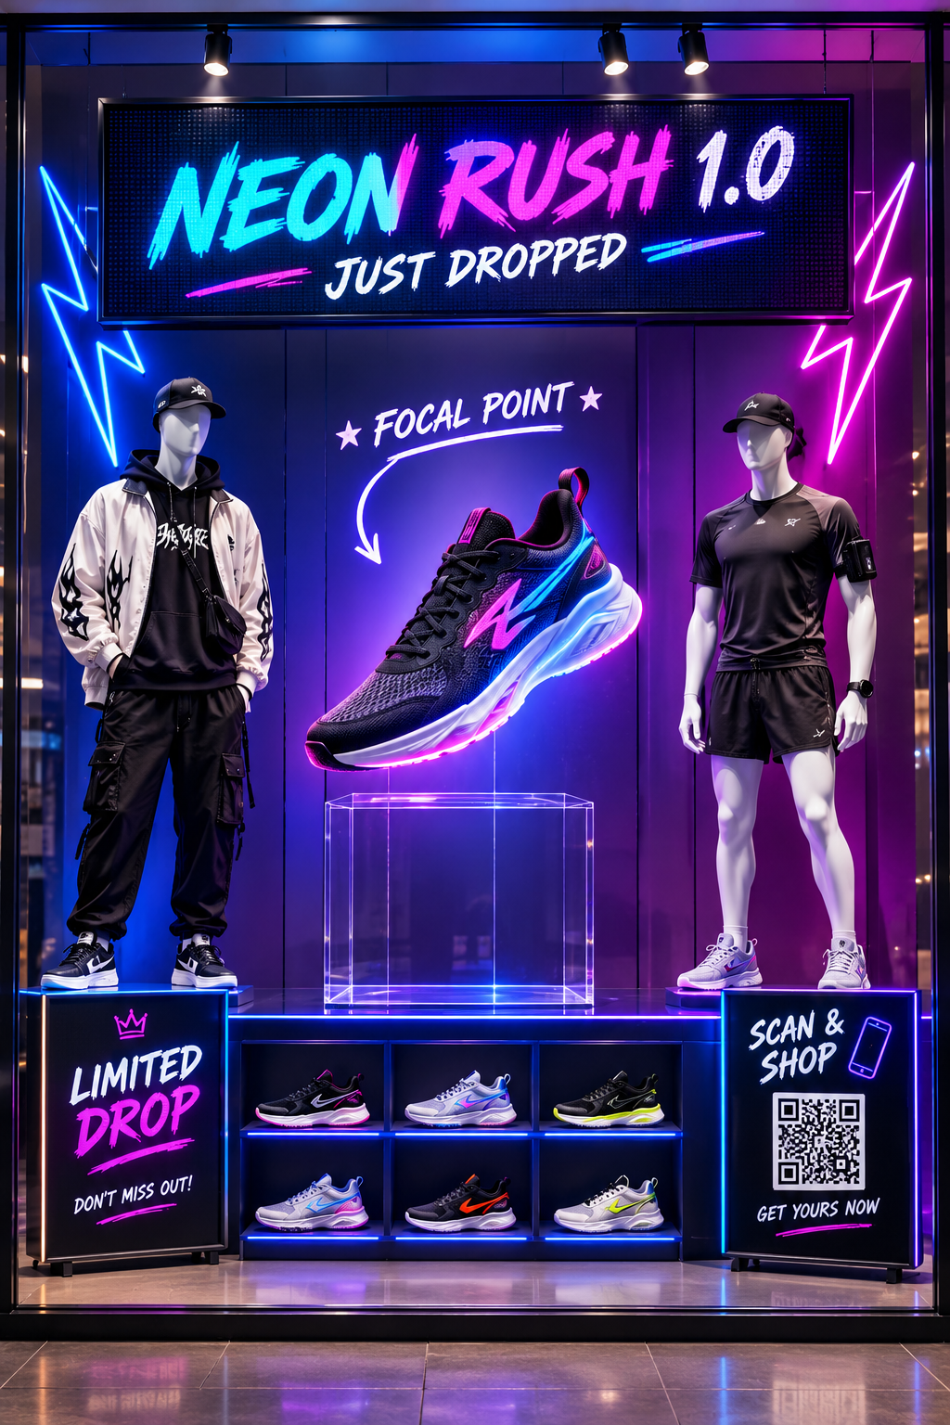

Key elements
A Nike store window display in a mall featuring multiple pairs of colorful Nike Dunk sneakers arranged on transparent acrylic shelves with reflections of the mall interior visible in the glass.
- Focal point: Centre mein one oversized/new sneaker ko transparent stand par rakhenge. Yeh sabse bright spotlight ke under hoga.
- Props: Neon lightning shapes, artificial smoke effect, colourful LED strips aur street-style backdrop use karenge.
- Signage: Top par large message—“Neon Rush 1.0: Just Dropped.” Side par “Limited Stock” aur “Scan & Shop” QR code hoga.
- Mannequins: Do mannequins ko casual Gen Z streetwear aur sporty outfit mein style karenge, taaki customers imagine kar sakein ki sneakers outfit ke saath kaise lagenge.
- Lighting: Blue, purple aur neon-green LED lighting use hogi, jo mall corridor se bhi visible rahe.
- Interaction: QR code scan karke customer shoe sizes, price aur online availability check kar sakega.

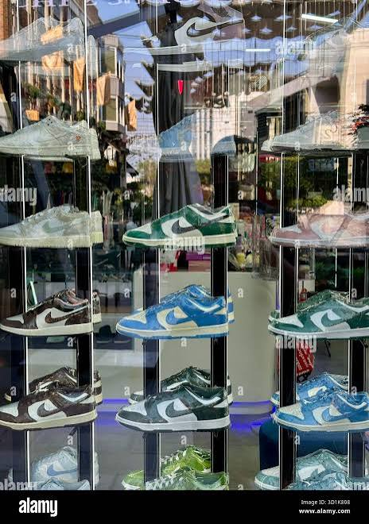

Goal yeh hai ki koi person mall mein walk karte waqt bright lighting, large sneaker aur “limited drop” message dekhkar ruk jaaye. Sneaker window displays mein colourful product arrangement aur prominent visual branding strong stopping power create kar sakte hain.

3. Mobile accessories shop redesign
Shop type: Small mobile accessories store
Main products: Headphones, chargers, cables, power banks, cases aur screen guards.
Change | Kaise arrange karunga/karungi | Sales kaise improve hogi

Change | Kaise arrange karunga/karungi | Sales kaise improve hogi
Best-seller wall | Entrance ke saamne “Top Picks” wall banaunga, jahan wireless earbuds, fast chargers aur power banks eye level par honge. | Customer enter karte hi popular items notice karega; product discovery fast hogi.
Product grouping | Chargers, cables aur power banks ko ek “Charging Zone” mein; headphones aur earbuds ko “Audio Zone” mein rakhenge. | Customer ko product dhoondhne mein confusion nahi hoga; related products compare karna easy hoga.
Demo table | Centre mein ek small demo table hoga, jahan customer headphones sound-test aur wireless charger test kar sakega. | Product use karke dekhne se trust aur purchase intention improve hoti hai.
Price signage | Har shelf par clear price tag, compatibility label—Android/iPhone/Type-C—and offer board lagayenge. | Customer ko staff ke wait ke bina information milti hai; decision faster hota hai.
Checkout add-ons | Billing counter ke paas low-cost items—charging cables, screen protectors, phone stands aur cable protectors—rakhenge. | Customers bill ke time inexpensive extra item impulse mein add kar sakte hain.
Combo offers | “Fast charger + Type-C cable”, “Earbuds + protective case” aur “Power bank + cable” combo packs banayenge. | Bundle value dikhne se average order value increase ho sakti hai.
Better lighting | Headphone display aur new-arrival shelf par focused white LED lights use karenge. | Premium products zyada attractive, clean aur visible lagenge.
Mobile-accessory shelves mein product labels aur category signs important hote hain. Example mein “Chargers & more” display mein chargers, cables, power banks aur headphones ek visible retail area mein show kiye gaye hain.

4. IPL merchandise in-store display
Campaign name: “Wear Your Team. Own The Season.”

Store layout plan
text

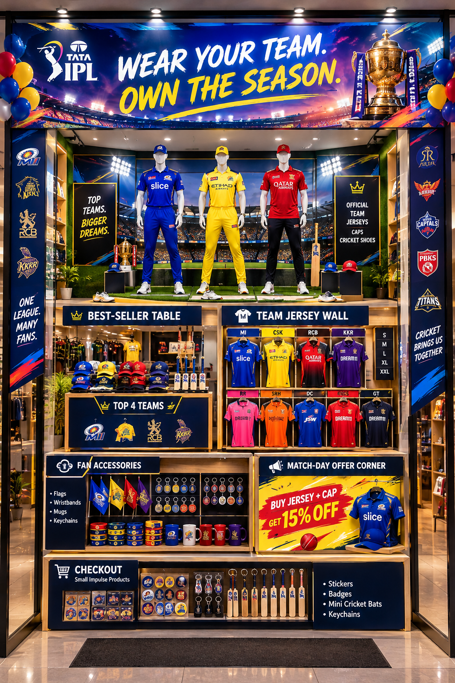Placement strategy
A retail store display featuring rows of colorful fan T-shirts in blue, red, yellow, black, and purple with logos, arranged on wall racks and a central table, with a banner reading "FAN T-SHIRTS" at the bottom.
- Entrance banner: Store ke entrance par large IPL campaign banner aur team-colour graphics lagenge. Isse customer ko door se hi campaign ka idea mil jayega.
- Mannequins at entrance: Entrance ke just andar three mannequins popular team jerseys, caps aur cricket shoes mein honge. Yeh visual inspiration create karega.
- Best-seller table in centre: Centre table par most popular jerseys aur caps rakhenge, kyunki yahan maximum foot traffic aata hai.
- Colour-coded jersey wall: Team ke hisaab se jerseys ko colour blocks mein arrange karenge—yellow, blue, red, purple, pink etc.—taaki fan apni favourite team ka product easily find kar sake.
- Offer corner: Back-right side par “Jersey + Cap combo” aur match-day discounts ka section rakhenge. Customer store explore karega aur last mein offer notice karega.
- Checkout impulse zone: Small affordable items—badges, stickers, wristbands, keychains aur mini bats—billing counter ke paas honge.
- Photo corner: Ek small “I Support My Team” backdrop aur prop bat rakha jayega. Customers photo share karenge, jisse free social-media visibility mil sakti hai.

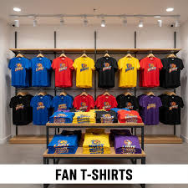
IPL merchandise stores commonly use colourful team jerseys, cricket bats, helmets aur fan apparel to create a clear sports-store atmosphere. Team jerseys ko colour-wise display karna product selection ko easier aur visually exciting bana sakta hai.

